UNITED STATES

SECURITIES AND EXCHANGE COMMISSION
Washington, D.C. 20549

FORM 8-K

CURRENT REPORT

PURSUANT TO SECTION 13 OR 15(d)
OF THE SECURITIES EXCHANGE ACT OF 1934

Date of report (Date of earliest event reported): January 11, 2016

ZIOPHARM Oncology, Inc.

(Exact Name of Registrant as Specified in Charter)

Delaware | 001-33038 | 84-1475642
(State or Other Jurisdiction | (Commission | (IRS Employer
of Incorporation) | File Number) | Identification No.)
One First Avenue, Parris Building 34, Navy Yard Plaza
Boston, Massachusetts |  | 02129
(Address of Principal Executive Offices) |  | (Zip Code)

(617) 259-1970

(Registrant’s Telephone Number, including Area Code)

Not applicable

(Former Name or Former Address, if Changed Since Last Report)

Check the appropriate box below if the Form 8-K is intended to simultaneously satisfy the filing obligation of the registrant under any of the following provisions:

- Written communications pursuant to Rule 425 under the Securities Act (17 CFR 230.425).

- Soliciting material pursuant to Rule 14a-12 under the Exchange Act (17 CFR 240.14a-12).

- Pre-commencement communications pursuant to Rule 14d-2(b) under the Exchange Act (17 CFR 240.14d-2(b)).

- Pre-commencement communications pursuant to Rule 13e-4(c) under the Exchange Act (17 CFR 240.13e-4(c)).

Item 7.01 Regulation FD Disclosure

On January 13, 2016, ZIOPHARM Oncology, Inc., or the Company will present the attached presentation at the 34th Annual J.P. Morgan Healthcare Conference in San Francisco, California being held on January 11 – 14, 2016.

A copy of the above referenced presentation is furnished as Exhibit 99.1 to this Current Report on Form 8-K. This information, including the information contained in the press release furnished as Exhibit 99.1, shall not be deemed “filed” for purposes of Section 18 of the Securities Exchange Act of 1934, as amended, and is not incorporated by reference into any of the Company’s filings, whether made before or after the date hereof, regardless of any general incorporation language in any such filing.

Item 9.01 |  |  | Financial Statements and Exhibits
(d) |  | Exhibits
Exhibit No. |  |  |  | Description
99.1 |  |  |  | Presentation of the Company dated January 13, 2016

2

SIGNATURES

Pursuant to the requirements of the Securities Exchange Act of 1934, the registrant has duly caused this report to be signed on its behalf by the undersigned hereunto duly authorized.

ZIOPHARM Oncology, Inc.

By: | /s/ Kevin G. Lafond
Date: January 11, 2016 | Name: Kevin G. Lafond
 | Title: Vice President Finance, Chief Accounting Officer and Treasurer
3

 |  |  |  | INDEX OF EXHIBITS
Exhibit No. |  | Description
99.1 |  | Presentation of the Company dated January 13, 2016
 |  | 4

Exhibit 99.1
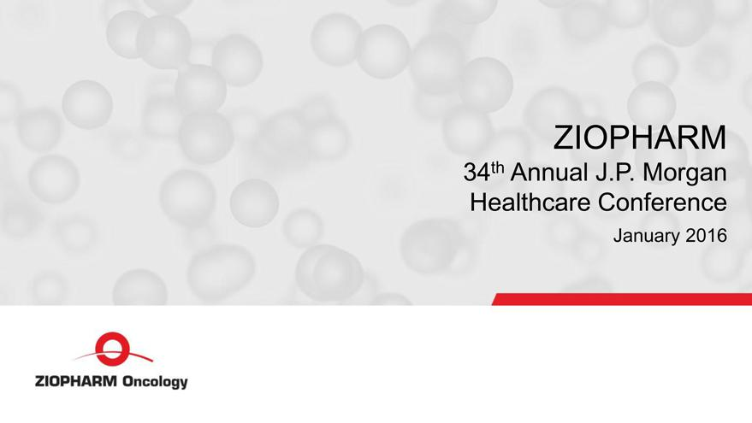

ZIOPHARM 34th Annual J.P. Morgan Healthcare Conference January 2016 ZIOPHARM Oncology

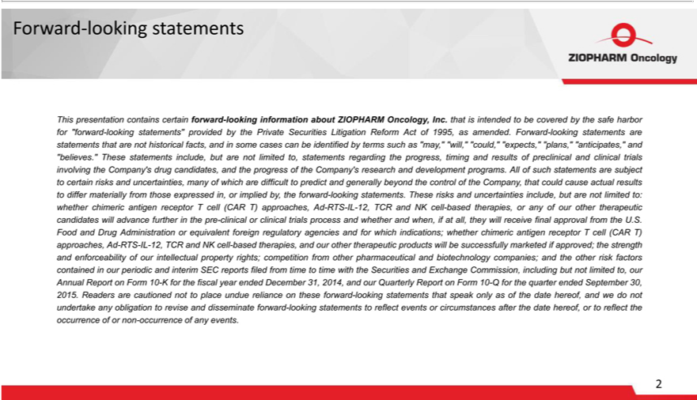

Forward-looking statements This presentation contains certain forward-looking information about ZIOPHARM Oncology, Inc. that is intended to be covered by the safe harbor for “forward-looking statements”
provided by the Private Securities Litigation Reform Act of 1995, as amended. Forward-looking statements are statements that are not historical facts, and in some cases can be identified by terms such as “may,”
“will,” “could,” “expects,” “plans,” “anticipates,” and “believes.” These statements include, but are not limited to, statements regarding he progress, timing and results of preclinical and clinical trials involving the
Company’s drug candidates, and the progress of the Company’s research and development programs. All of such statements are subject to certain risks and uncertainties, many of which are difficult to predict and
generally beyond the control of the Com | any, that could cause actual results to differ materially from those expressed in, or implied by, the forward-looking statements. These risks and |  |  | include, but are not
limited to: whether chimericantigen receptor T cell (CAR T) approaches, Ad-RTS-IL-12, TCR and NK cell-based therapies, or any of our other therapeutic candidates will advance furtheruncertaintiesthepre-clinical or clinical
trials process and whether and w n, if at all, they will receive final approval from |  | U.S. Food and Drug Administration or equivalent foreign regulatory agencies and for which indications; whether chimeric antigen
receptor T cell (CAR T) approaches, Ad-RTS-IL-12, TCR and NK cell-based therapies, and our other therapeutic products will be successfully marketed if approved; the strength and enforceability of our intellectual
property rights; competition from other pharmaceutical and biotechnology companies; and the other risk factors contained in our periodic and interim SEC reports filed from time to time with the Securities and
Exchange Commission, including but not limited to, our Annual Report on Form 10-K for the fiscal year ended December 31, 2014, and our Quarterly Report |  |  | Form 10-Q for the quarter ended September 30, 2015.
Readers are cautioned not to place undue | liance on these forward-looking statements that speak only as of the date hereof, and we do not undertake any obligation to revise and disseminate forward-looking
statements to reflect events or circumstances after the date hereof, or to reflect the occurrence of or non-occurrence of any events. ZIOPHARM Oncology

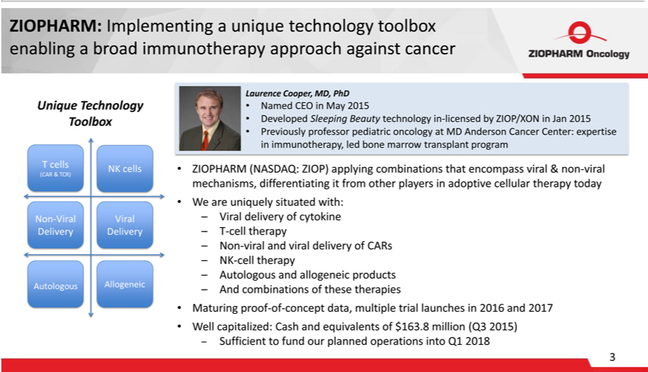

ZIOPHARM:SleepingBeautyImplementingtechnology inaunique-licensedtechnologybyZIOP/XONtoolboxin enablingJan2015 a• broadPreviouslyimmunotherapyprofessorpediatricapproachoncologyagainstferentiatingcancerMDUniqueAndersonTechnologyCancerCenter:ToolboxexpertiseLaurencein immunotherapyCooper,MD,PhD,led• boneNamedmarrowCEO intransplantMay2015program•Developed•
ZIOPHARM (NASDAQ: ZIOP) applying combinations that encompass viral & non-viral mechanisms, dif it from other players in adoptive cellular today • W are uniquely situated with: – Viral
trialdeliverylaunchesofcytokine2016– andT-cell2017therapy•Well– capitalized:Non-viralandCashviralanddeliveryequivalentsofCARsof$163.8–NK-millioncelltherapy(Q3 2015)–Autologous–Sufficientand allogeneictofundourproductsplanned –operationsAndcombinationsintoQ12018ofthese therapies • Maturing proof-of-concept data, multiple

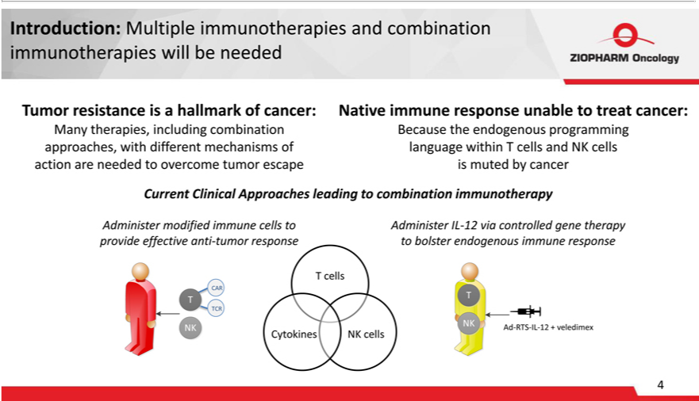

Introduction: Multiple immunotherapies and combination immunotherapies will be needed Tumor resistance is a hallmark of cancer: Native immune response unable to treat cancer: Many therapies, including combination Because the endogenous programming approaches, _{modified}withferent mechanisms of language within T cells and NK cells action are needed to overcome tumor escape is muted_{endogenous}bycacer Current Clinical
Approaches^{cells} leading to combination immunotherapy Administer immune cells to Administer IL-12 via controlled gene therapy provide effective anti-tumor response to bolster immune response T
cells T T cells Ad-RTS-IL-12 + veledimex

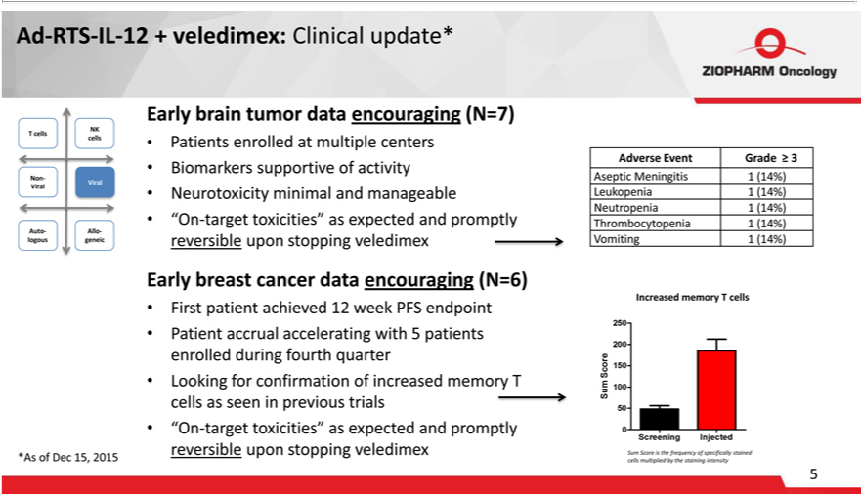

Ad-RTS-IL-12 + veledimex: Clinical update* Early brain tumor data encouraging (N=7) • Patients enrolled at multiple centers • Biomarkers supportive of activity • Neurotoxicity minimal and manageable • “On-target toxicities” as expected and promptly reversible upon stopping veledimex Early breast cancer data encouraging (N=6) • First patient achieved 12 week PFS endpoint • Patient accrual accelerating with 5 patients enrolled during fourth quarter • Looking for confirmation of increased memory T cells as seen in previous trials • “On-target toxicities” as expected and promptly reversible upon stopping veledimex Auto-logous Auto-logous T cells NK cells Viral Allo-geneic Adverse Event Grade ? 3 Aseptic Meningitis 1 (14%) Leukopenia 1 (14%) Neutropenia 1 (14%) Thrombocytopenia 1 (14%) Vomiting 1 (14%) Increased memory T cells Sum Score is the frequency of specifically stained cells multiplied by the staining intensity

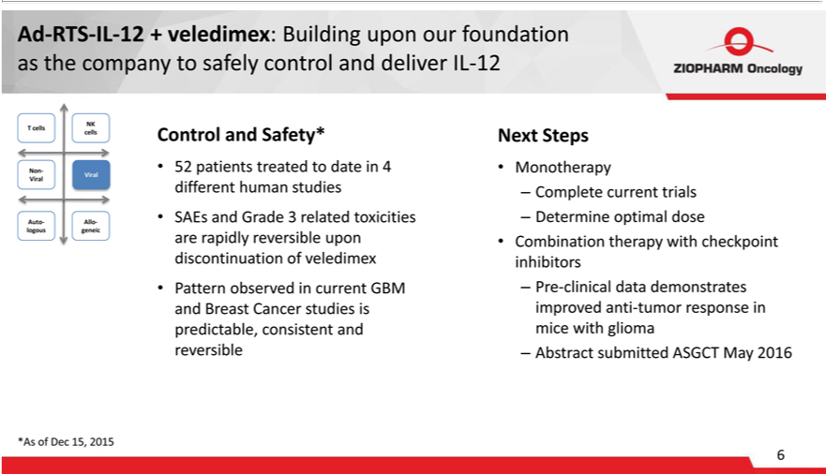

Ad-RTS-IL-12 + veledimex: Building upon our foundation as the company to safely control and deliver IL-12 NK T cells cells Non- Viral Viral Auto- Allo-logous geneic NK T cells cells Non- Viral Viral Auto- Allo-logous g_{reversible}nicNK T cells cells Non- Viral Viral Auto- Allo-logous geneic *As of Dec 15, 2015 Control and Safety* • 52 patients treated to date in 4 different human studies • SAEs and Grade 3 related toxicities are
rapidly up^{dose}ndiscontinuation of veledimex • Pattern observed in current GBM and Breast Cancer studies is predictable, consistent and reversible Next Steps • Monotherapy – Complete current trials –
Determine optimal • Combination therapy with checkpoint inhibitors – Pre-clinical data demonstrates improved anti-tumor response in mice with glioma – Abstract submitted ASGCT May 2016

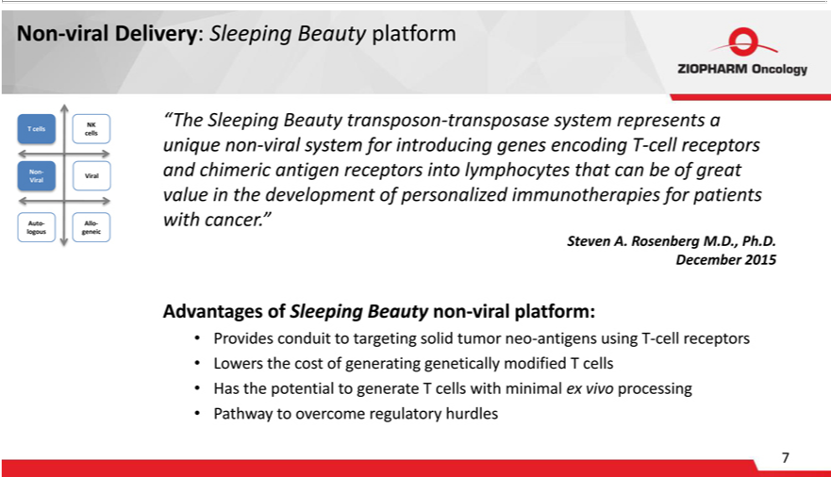

devel pment introducing
Non-viral Delivery: Sleeping Beauty platform “The Slee ing Beauty transposon-transposase system represents a unique non-viral system for genes encoding T-cell receptors and chimeric antigen receptors
into lymphocytes that can be of great value in the ^{neo} of personalized immunotherapies for patients with cancer.” Steven A. Rosenber M.D., Ph.D. December 2015 Advantages of Sleeping Beauty non-viral _{processing}latform:• Provides conduit to targeting solid tumor -antigens using T-cell receptors • Lowers the cost of generating genetically modified T cells • Has the potential to generate T cells with minimal ex vivo
• Pathway to overcome regulatory hurdles NK T cells cells Non- Viral Viral Auto- Allo-logous geneic

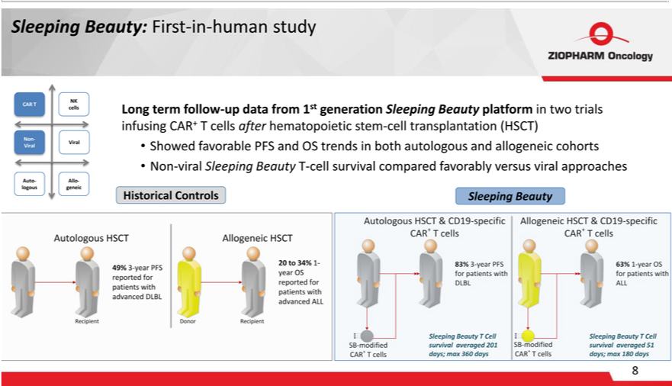

Sleeping Beauty: First-in-human study NK CAR T cells Non- Viral Viral Auto- Allo-logous geneic Long term fo_{allogeneic}w-updata from 1st generation Sleeping Beauty_{cell}patform in two trials infusing CAR+ T cells after

hematopoietic stem-cell transplantation (HSCT) • Showed favorable PFS and OS trends in both autologous and cohorts • Non-viral Sleeping Beauty T- survival compared favorably versus viral approaches Historical Controls Sleeping Beauty

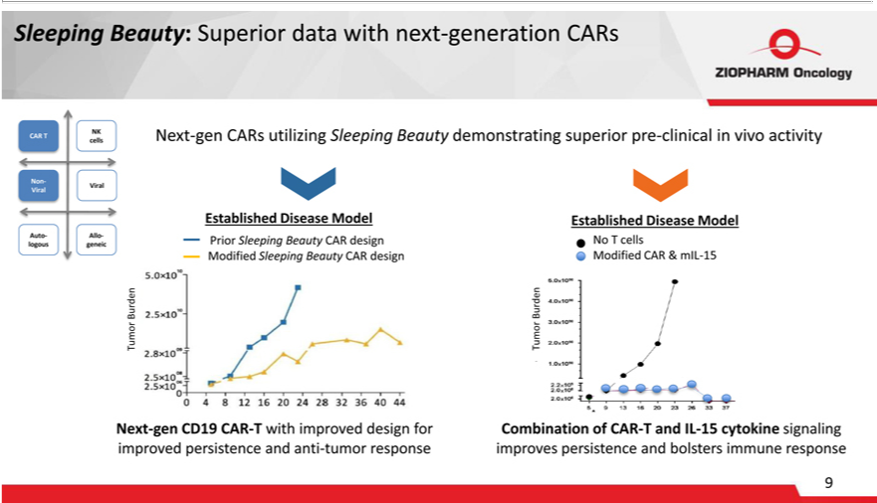

Sleeping Beauty: Superior data with next-generation CARs Next-gen CARs utilizing Sleeping Beauty demonstrating superior pre-clinical in vivo activity Established Disease Model Prior Sleeping Beauty CAR design Modified Sleeping Beauty CAR design Established Disease Model No T cells Modified CAR & mIL-15 NK CAR T cells Non- Viral Viral Auto- Allo-logous geneic Bur den Tumor Next-gen CD19 CAR-T with improved design for improved persistence and anti-tumor response Bu rden Tumor Combination of CAR-T and IL-15 cytokine signaling improves persistence and bolsters immune response

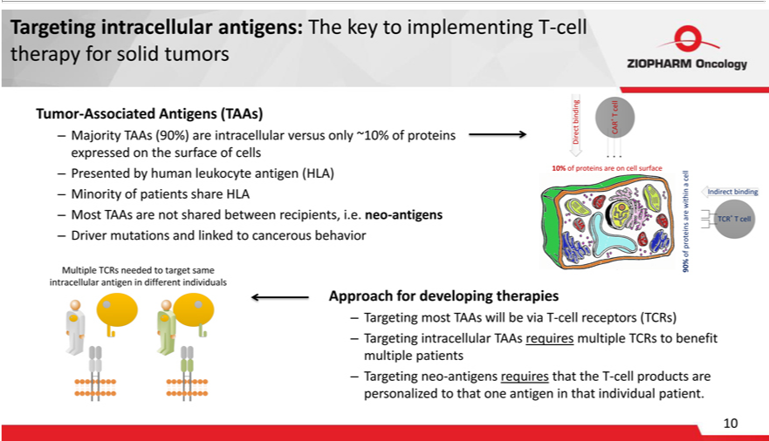

Targeting intracellular antigens: The key to implementing T-cell therapy for solid tumors Tumor-Associated Antigens (TAAs) – Majority TAAs (90%) are intracellular versus only ~10% of proteins expressed on the surface of cells – Presented by human leukocyte antigen (HLA) – Minority of patients share HLA – Most TAAs are not shared between recipients, i.e. neo-antigens – Driver mutations and linked to cancerous behavior Approach for developing therapies – Targeting most TAAs will be via T-cell receptors (TCRs) – Targeting intracellular TAAs requires multiple TCRs to benefit multiple patients – Targeting neo-antigens requires that the T-cell products are personalized to that one antigen in that individual patient.

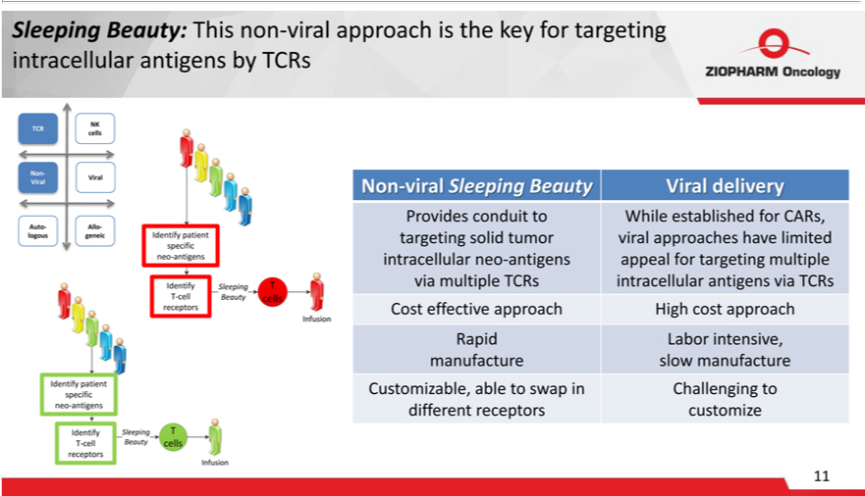

Sleeping Beauty: This _{conduit}non-vral approach_{established}thekey for targeting _{geting}racellular antigens by TCRs NK TCR cells Non- Viral Viral Auto- Allo-logous geneic neo-antigens receptors Non-viral al Sleeping Beauty Viral

delivery eliv Provides to While for CARs, tar solid tumor viral approaches have limited intracellular neo-antigens appeal for targeting multiple via multiple TCRs intracellular antigens via TCRs Cost effective approach High cost approach Rapid Labor intensive, manufacture slow manufacture Customizable, able to swap in Challenging to different receptors customize Identify neo-antigens receptors

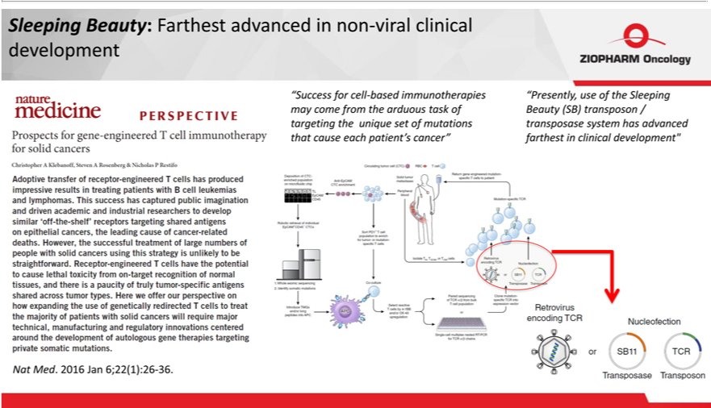

Sleeping Beauty: Farthest advanced in non-viral clinical development Nat Med. 2016 Jan 6;22(1):26-36. “Success for cell-based immunotherapies “Presently, use of the Sleeping may come from the arduous task of Beauty (SB) transposon / targeting the unique set of mutations transposase system has advanced that cause each patient’s cancer” farthest in clinical development”

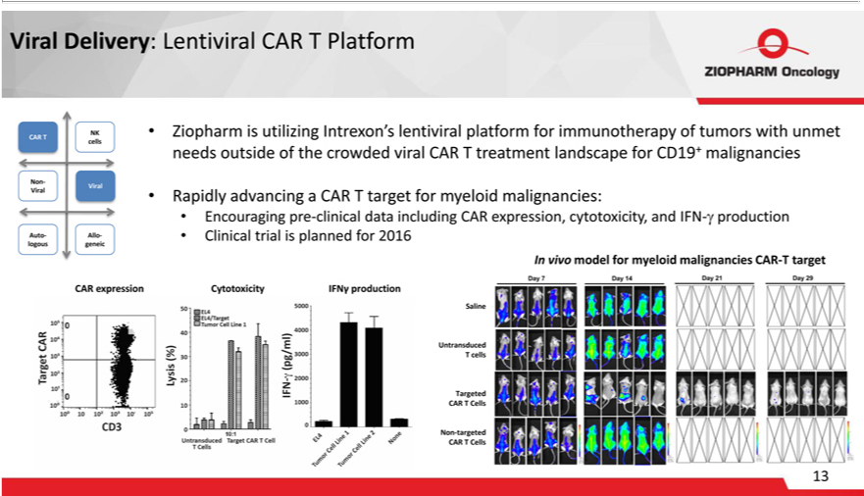

Viral Delivery: Lentiviral CAR T _{Platform} • Ziopharm is utilizing_{malignancies:}Intrexon’ lentiviral platform for immunotherapy of tumors with unmet needs outside of the crowded viral CAR T treatment landscape for CD19+

malignancies • Rapidly advancing CAR T target for myeloid • Encouraging pre-clinical data including CAR expression, cytotoxicity, and IFN-ã production • Clinical trial is planned for 2016 CAR expression Cytotoxicity IFNãproduction Saline Untransduced T cells Targeted CAR T Cells Non-targeted CAR T Cells NK CAR T cells Non- Viral Viral Auto- Allo-logous geneic In vivo model for myeloid malignancies CAR-T target Saline Untransduced T cells Targeted CAR T Cells Non-targeted CAR T Cells

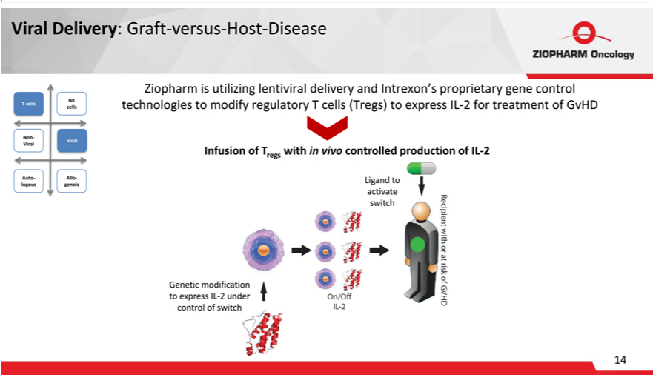

Viral Delivery: Graft-versus-Host-Disease Ziopharm is utilizing lentiviral delivery and Intrexon’s proprietary gene control technologies to modify regulatory T cells (Tregs) to express IL-2 for treatment of GvHD NK T cells cells Non- Viral Viral Auto- Allo-logous geneic Infusion of Tregs with in vivo controlled production of IL-2 Genetic modification to express IL-2 under control of switch

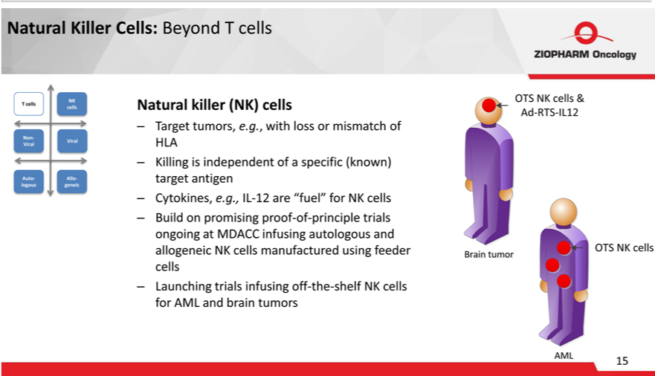

Natural Killer Cells: Beyond T cells Natural killer (NK) cells – Target tumors, e.g., with loss or mismatch of HLA – Killing is independent of a specific (known) target antigen – Cytokines, e.g., IL-12 are “fuel” for NK cells – Build on promising proof-of-principle trials ongoing at MDACC infusing autologous and allogeneic NK cells manufactured using feeder cells – Launching trials infusing off-the-shelf NK cells for AML and brain tumors NK T cells cells Non- Viral Viral Auto- Allo-logous geneic

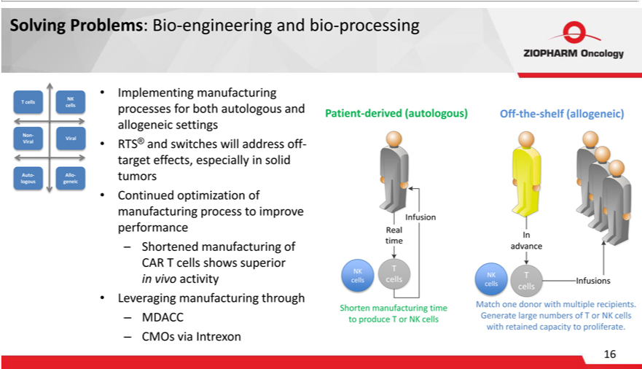

Solving Problems: Bio-engineering and bio-processing NK T cells cells Non- Viral Viral Auto- Allo-logous geneic Implementing manufacturing processes for both autologous and allogeneic settings RTS® andswitcheswilladdressof-targeteffects,especiallysolidtumorsContinuedoptmizationofprocesstoimproveperformance–ShortenedmanufacturingofCARTcellsshowssuperiorvivo manufacturing derived manufacturing manufacturingactivityLeveragingthrough–MDACC–CMOsviaIntrexonPatient-Of-the-shelf(allogeneic)NKcellsNKcellsMatchonedonorwithmultiplerecipients.Shortentime (autologous)GeneratelargenumbersofTorNKcellstoproduceTorNKcellswithretainedcapacityproliferate.

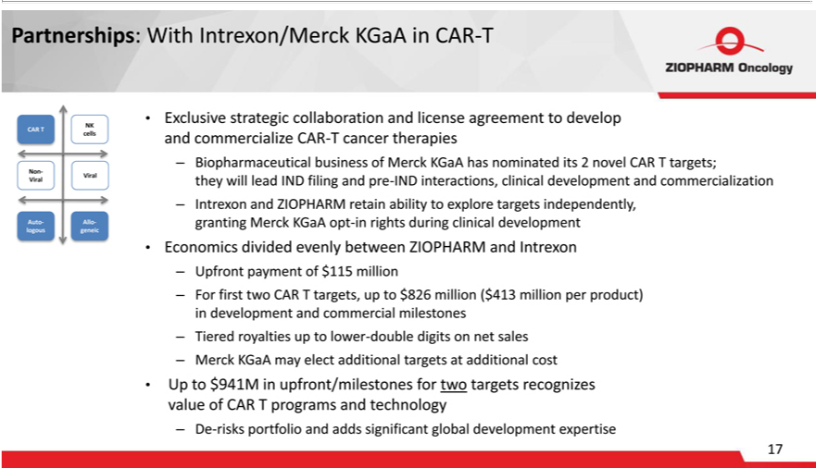

Partnerships: With Intrexon/Merck KGaA in CAR-T • Exclusive strategic collaboration and license agreement to develop and commercialize CAR-T cancer therapies ? Biopharmaceutical business of Merck KGaA has nominated its 2 novel CAR T targets; they will lead IND filing and pre-IND interactions, clinical development and commercialization ? Intrexon and ZIOPHARM retain ability to explore targets independently, granting Merck KGaA opt-in rights during clinical development • Economics divided evenly between ZIOPHARM and Intrexon ? Upfront payment of $115 million ? For first two CAR T targets, up to $826 million ($413 million per pr^{for}duct) in development and commercial milestones ? Tiered royalties up to lower-double digits on net sales ? Merck KGaA may elect additional targets at additional cost • Up^{Auto}$941M in

upfront/milestones two targets recognizes value of CAR T programs and technology ? De-risks portfolio and adds significant global development expertise NK CAR T cells Non- Viral Viral - Allo-logous geneic

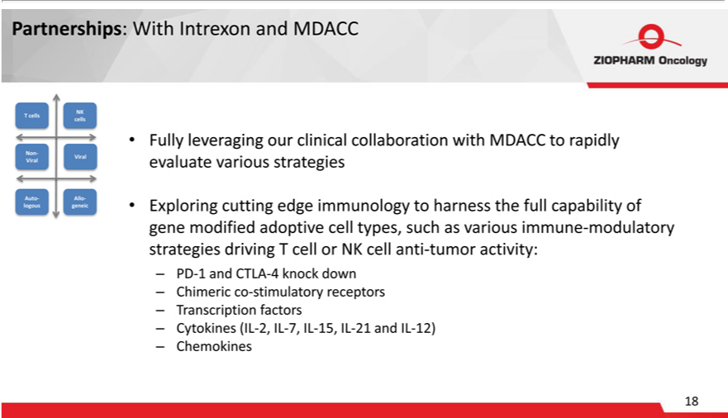

Partnerships: With Intrexon and MDACC • Fully leveraging our clinical collaboration with MDACC to rapidly evaluate various strategies • Exploring cutting edge immunology_{stimulatory}harness the full capability of gene

modified adoptive cell types, such as various immune-modulatory strategies driving T cell or NK cell anti-tumor activity: ? PD-1 and CTLA-4 knock down ? Chimeric co- receptors ? Transcription factors ? Cytokines (IL-2, IL-7, IL-15, IL-21 and IL-12) ? Chemokines NK T cells cells Non- Viral Viral Auto- Allo-logous geneic

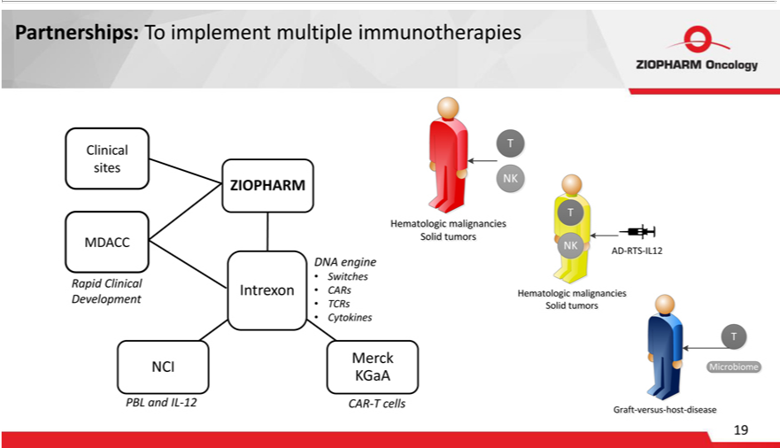

Partnerships: To implement multiple immunotherapies Clinical sites ZIOPHARM MDACC DNA engine • Switches Rapid Clinical Intrexon • CARs Development • TCRs • Cytokines Merck NCI KGaA PBL and IL-12 CAR-T cells CAR-T cells

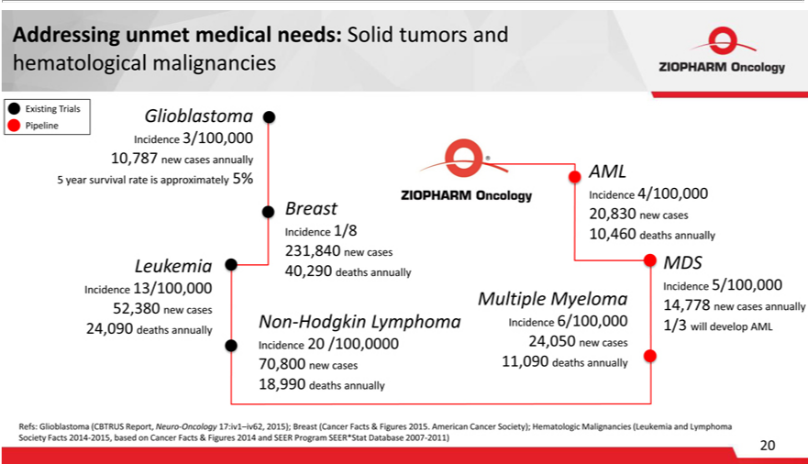

Addressing unmet medical needs: Solid tumors and hematological malignancies Existing Trials Pipeline Trials Glioblastoma Incidence 3/100,000 10,787 new cases annually 5% AML 5 year survival rate is approximately Incidence 4/100,000 Breast 20,830 new cases Incidence 1/8 10,460 deaths annually 231,840 new cases Leukemia MDS 40,290 deaths annually Incidence 13/100,000 Multiple Myeloma Incidence _{5/100,000} 52,380 new cases 14,778 new cases annually ,090 Non-Hodgkin Lymphoma Incidence 6/100,000 1/3 will develop AML 24 deaths annually Incidence 20 /100,0000 24,050 new cases 70,800 new cases 1,090 deaths annually 18,990 deaths annually Refs: Glioblastoma (CBTRUS Report, Neuro-Oncology 17:iv1–iv62, 2015); Breast (Cancer Facts & Figures 2015. American Cancer Society); Hematologic Malignancies (Leukemia and Lymphoma Society Facts 2014-2015, based on Cancer Facts & Figures 2014 and SEER Program SEER*Stat Database 2007-2011)

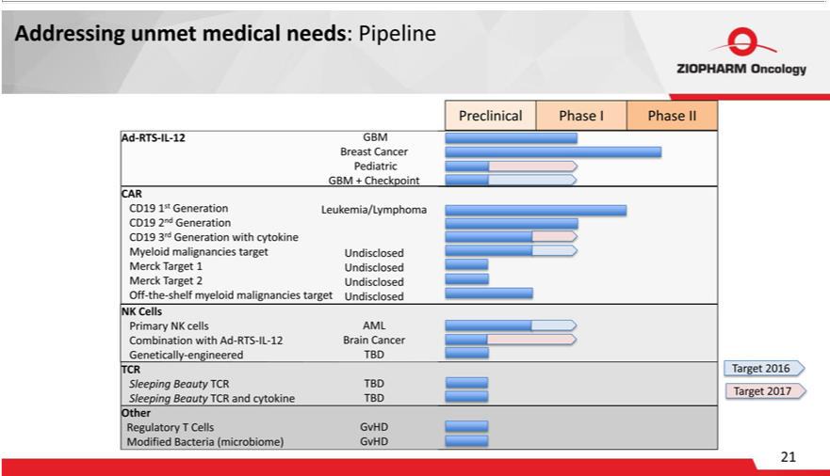

Addressing unmet medical needs: Pipeline Preclinical Phase I Phase II Ad-RTS-IL-12 GBM Breast Cancer Pediatric GBM + Checkpoint CAR CD19 1st Generation Leukemia/Lymphoma CD19 2nd Generation CD19 3rd Generation with cytokine Myeloid malignancies target Undisclosed Merck^{TBD}arget 1 Undisclosed Merck Target 2 Undisclosed Off-the-shelf myeloid malignancies target Undisclosed NK Cells Primary NK cells

AML Combination with Ad-RTS-IL-12 Brain Cancer Genetically-engineered TCR Target 2016 Sleeping Beauty TCR Target 2017 Sleeping Beauty TCR and cytokine TBD Other Regulatory T Cells GvHD Modified Bacteria (microbiome) GvHD 21

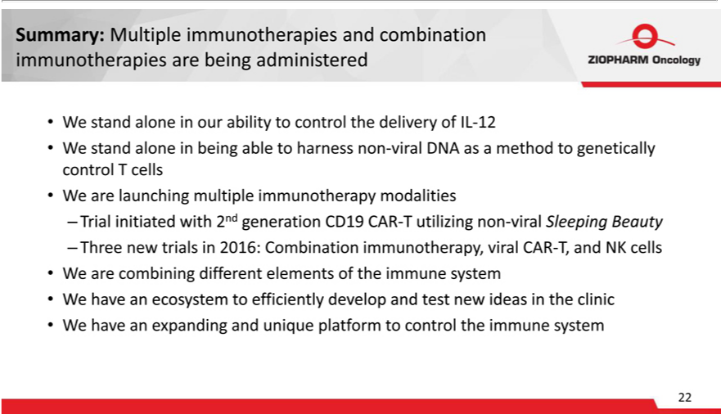

_{Summary:} Multiple immunotherapies and combination immunotherapies are being administered • We stand alone in our ability to control the delivery of IL-12 • We stand alone in being able to harness non-viral DNA as method to genetically control T cells • We are launching _{multiple} immunotherapy modalities – Trial initiated with 2nd _{generation} CD19 CAR-T utilizing non-viral Sleeping Beauty – Three new trials in 2016: Combination immunotherapy, viral CAR-T, and NK cells • W are combining different elements of the immune system • W have an ecosystem to efficiently develop and test new ideas in the clinic • We have an expanding and unique platform to control the immune system

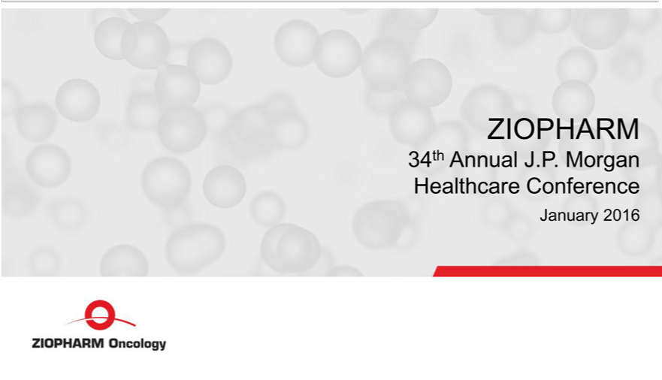

ZIOPHARM 34th Annual J.P. Morgan Healthcare Conference January 2016 ZIOPHARM Oncology

